**TYPES OF MANUAL TESTING**

1. SMOKE TESTING

* The purpose of smoke testing is to determine whether the build software is testable or not.
* It is a time-saving process. It reduces testing time because testing is done only when the key features of the application are not working or if the key bugs are not fixed.
* we verify every build is testable or not; hence it is also known as **Build Verification Testing.**

EXAMPLE

* Suppose, we are using an eCommerce site,
* Core working of this site should be login, specific search, add an item into the cart, add an item into the favorite, payment options, etc.
* Here we are testing function to place an order.
* After testing, the tester has to be sure and confident about the functioning of the function of the application

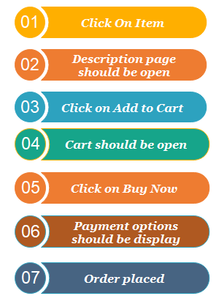.

* If this function is working correctly, then tester will pass it in testing and test the next function of the same application.

1. USER INTERFACE TESTING

* UI testing is the process to validate both the functionality and visual aspects of the User Interface of an application.
* It focuses more on testing what the end users see and interact with instead of the inner workings on the backend.
* Testing is to ensure the functionalities of software application work as per specifications by checking screens and controls like menus, buttons, icons, etc.
* A user does not see the source code.
* The interface is visible to the user.
* Especially the focus is on the design structure, images that they are working properly or not.

EXAMPLE

* This is what the application looks like:
* 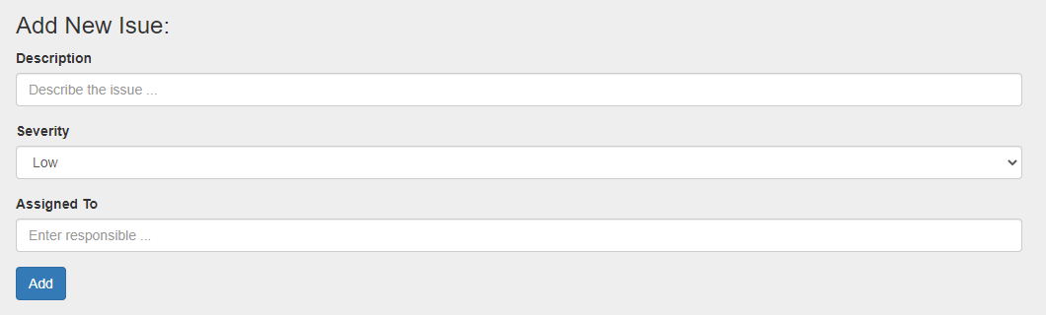After filling the fields and clicking on “Add,” we can see the issue created:

 some examples of possible test cases:

* **Required fields.**

Verify whether the “description” and the “assigned to” fields have validation against leaving them blank. Also, it’s a best practice to identify required fields with an asterisk.

* **Data.**

Verify that only allowable data types are accepted. If it requires a phone number, does it prevent letters? Verify that users can’t exceed the acceptable number of characters for a given field. Verify that “assigned to” only includes appropriate personnel.

* **Spelling.**

 Check for spelling mistakes in the interface (in this case, there’s a type in “issue.”)

* **Interaction.**

Verify all buttons are clickable, and the dropdown list works as expected. Verify that data entered on the first panel is properly reflected on the results panel (description, severity, and assignee).

1. USABILITY

* It is primarily used in user-centered interaction design on order to check the usability or ease of using a software product.
* The implementation of usability testing requires an understanding of the application, as it is extensive testing.
* usability testing is performed from an end-user viewpoint to verify if the system is efficiently working or not.
* it makes sure that the developed software is straightforward while using the system without facing any problem and makes end-user life easier.
* 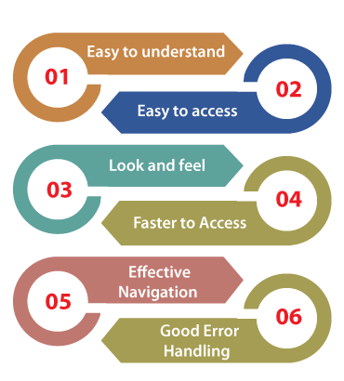
* EXAMPLE
* We are taking one **banking application** where we produce the application for the manager.
* Note: Here, the Manager is the end-user.
* Now, if the end-user (manager) starts using the application in front of the test engineers
* Suppose two test engineer sits at the back of the end-user while he/she is using the application and takes the report of the defect as a developer to check whether the end-user is using the application in a right way or not.
* And the end-user (manager) will check the application step by step because he/she knows that the Test engineer is watching him/her.S
* Note: Generally, the professional test engineers do not perform usability testing because they know where exactly the particular feature will fail and how it works.  
  Therefore, a test engineer becomes user-friendly with the application.  
  So only the end-user should do the usability testing for better results.